**Object detection**

To learn about object detection we first learn about object localization.

**Object localization**

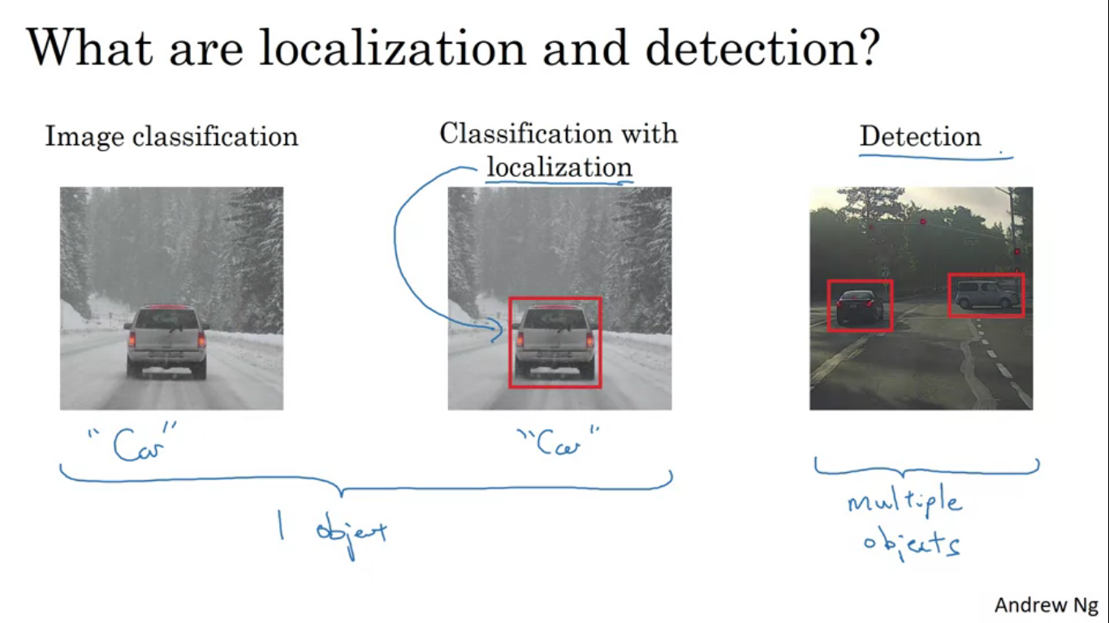

Classification me only say it is a car but in classification with localization, not only we have to say it is a car but the algorithm also is responsible for putting a bounding box. The term localization refers to figuring out where in the picture is the car we have detected. Detection problem is that there might be multiple objects in the image and you have to detect/localize them all. For autonomous driving application we might need to do this for other pedestrians, motorcycles and other objects.

Classification and classification with localization usually have 1 object in the middle of image we are trying to recognise.

In detection problems there can be multiple objects of different categories.

We know how classification works, for localization we can change the NN to have a few more output units that output a binding box. We can have NN output 4 more numbers bx, by, bh and bw. These four numbers parameterise the bounding box of the detected object.

Notation

Upper left of the image denoted as (0,0) and the lower right is (1,1)

To specify the bounding box, the red rectangle requires specifying the mid point which is bx,by as well as the height and width being bh and bw. So in the example the ideal bx=0.5, by=0.7, bh=0.3 and bw=0.4.

Defining the target label Y

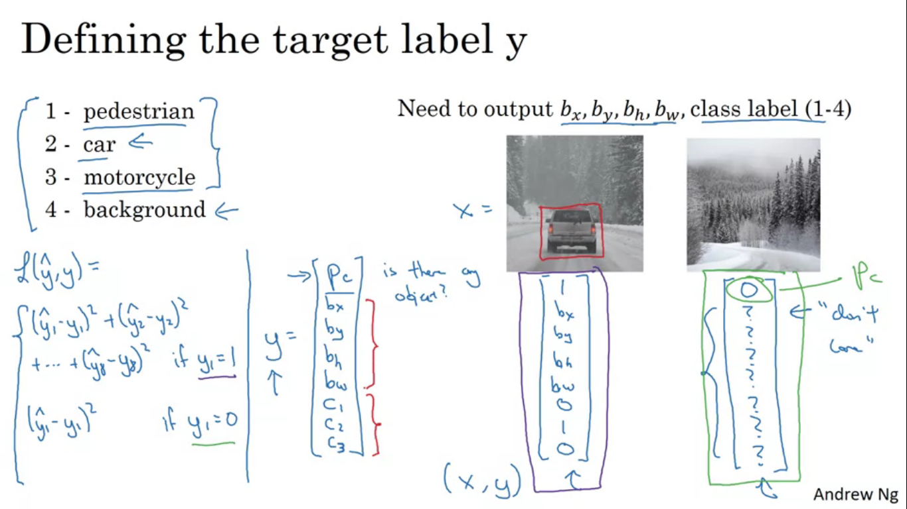

NN now outputs the four numbers as well as the class label. So to define the target label Y as follows

It is a vector where the first component pc will be is there an object. So if the object = classes 1,2,3 then pc = 1 else it will be 0. Next will be bx, by, bh and bw for the bounding box we created. If pc= 1 then c1,c2,c3 whether class 1/2/3. Assuming at most one object appears in the image. Among c1,c2,c3 at most one of them should be equal to 1. That is if there is an object in the image. What if there is no object in the image. Then in that case pc = 0 and we do not care about other things.

Y here has 8 components so loss will be as shown. There are two cases y1 =1 and y1 = 0. For classes we can use log likelihood, for bounding boxes we can use squared error, pc we can use logistic regression loss.

**Landmark detection**

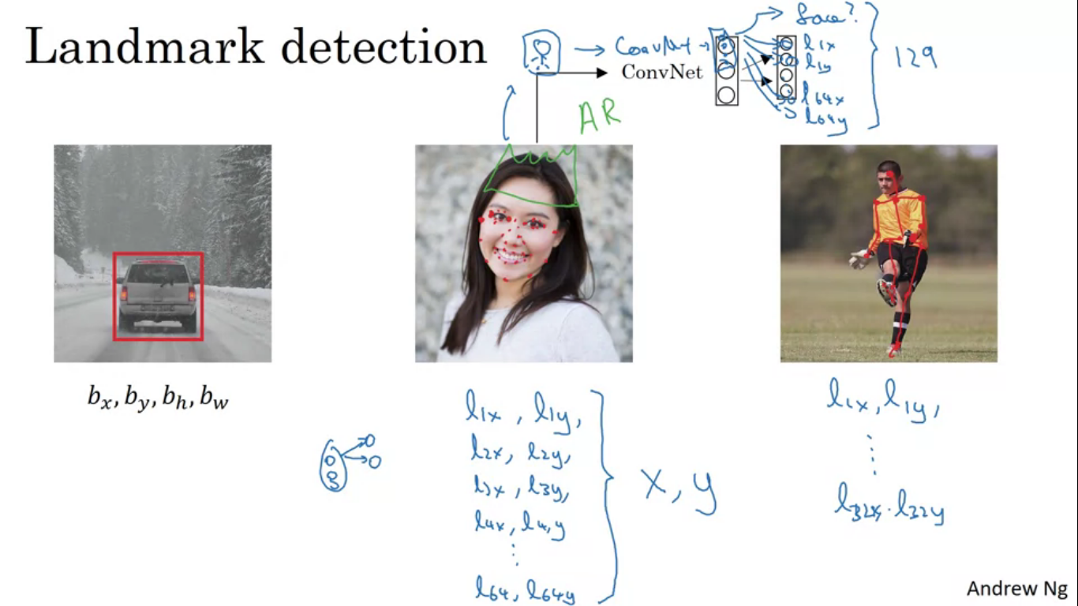

You can have a NN output X and Y coordinates of important points in image called landmarks. For example we are building a face recognition application and we want to determine where is the corner of someone eye. So we can have final layer and have it output two more numbers which will be lx and ly. What if we want to tell all four corners of the eyes. If we call the points 1st,2nd,3rd,4th then we can now output l1x,l1y,l2x,l2yml3x,l3y,l4x,l4y. So we can define some numbers let’s say 64 for 64 landmarks on the face. By selecting a landmark and generating a labelled training set containing all the landmarks we can then have the NN tell where are all the key positions on a face. So we can have a conv net with output as 129 units, 1 for if a face or not and then 64*2 = 128 for lx and ly of the landmark. We need to have a set of images as well as labels where someone will have had to go through and laboriously annotate all of these landmarks.

Another example is if we are interested in people pose detection we can also define midpoint of chest left shoulder, left elbow , wrist and have a NN annotate key positions output all the points I’m annotating, can have the NN output the pose of the person.

**Object detection using sliding windows detection algorithm**

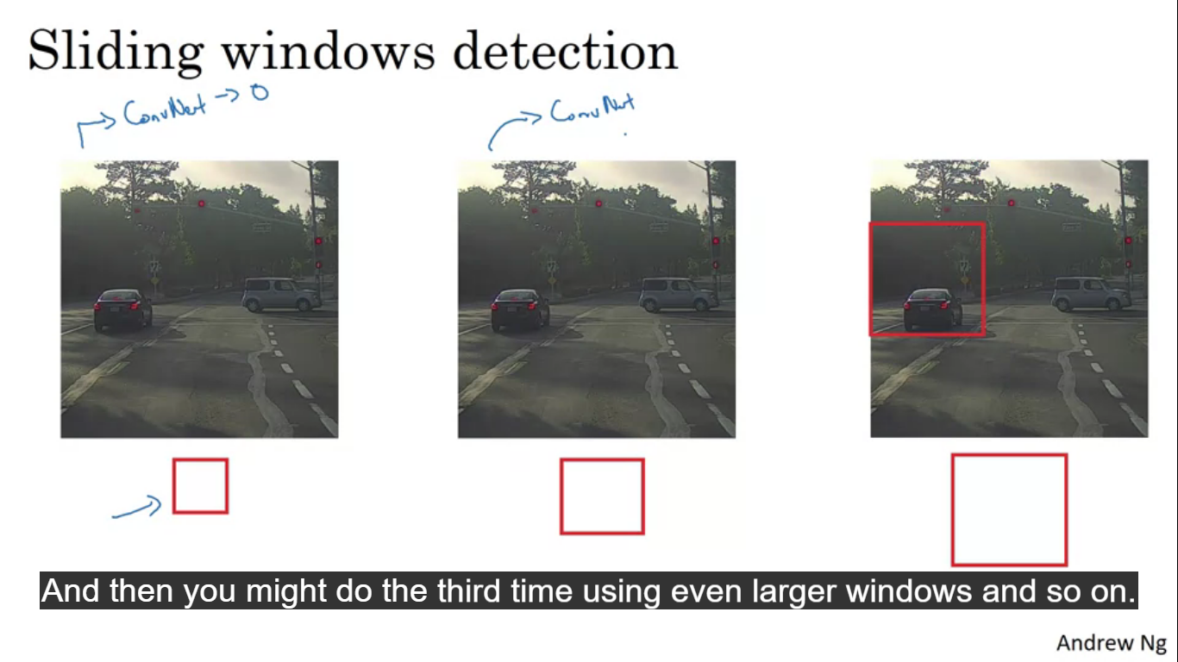

For building a car detection system, we can create a labelled set x and y with closely cropped images of cars. Given this labelled training set we can then create a convent that inputs an image and outputs Y. Once we have created this conv net we can then use it in sliding windows detection. So we have our conv net as small red rectangle and in that we input a small rectangular region and make the conv net make a prediction. Then we shift the red square and send in the second image into the conv net. We keep on repeating the same process. And then we repeat the process with a larger window.

So long there is a car somewhere in the image there will be a window where we detect a car.

Disadvantage of sliding windows detection is the computational cost.

Convolution implementation of sliding windows

**To do so let’s first see how we can turn FC layers into conv layers.**

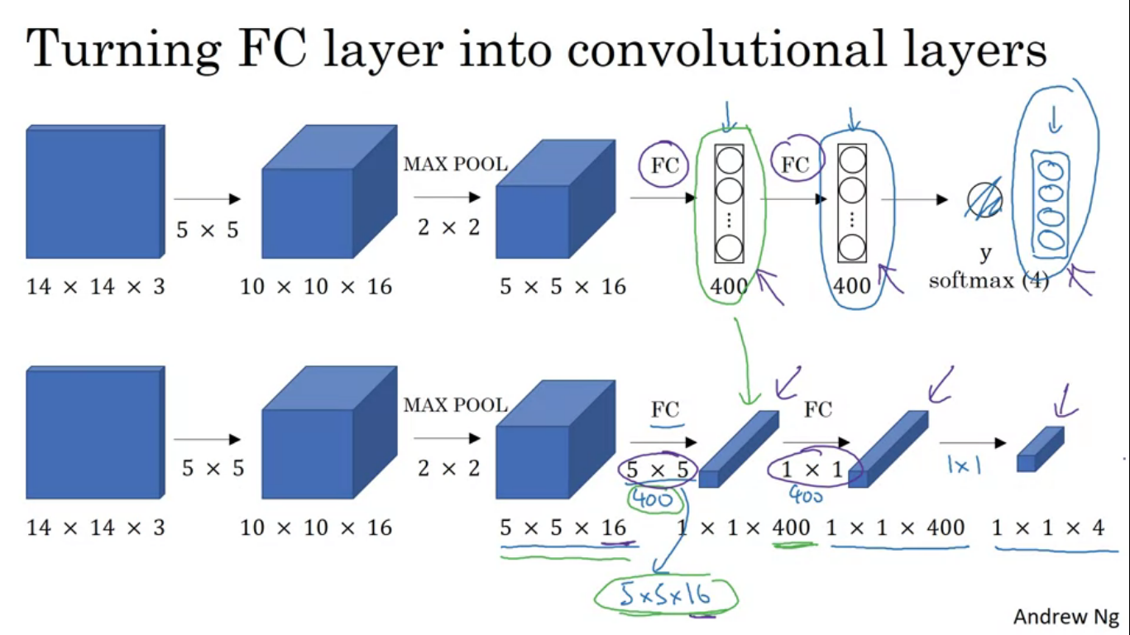

So input is 14x14x3, it uses 5x5 filters, 16 of them so the output size becomes 10x10x16 and then does a 2x22 max pool to reduce it to 5x5x16. Then it has a FC layer to connect 400 units then another FC layer followed by a softmax that finally gives the output. To convert the FC layer into conv layer we use 400, 5x5 filters. So if we take a 5x5x16 image and convolve it with a 5x5 filter then the filter size is 5x5x16 because the convention is that the filter looks across all 16 channels. So the output will be 1x1 and if we have 400 of these 5x5x16 filters then the output dimension is going to be 1x1x400. So rather than viewing them as a set of nodes we view them as volumes. Each of these 400 values is some arbitrary linear function of these 5x5x16 activations from the previous layers.

Next to implement next conv layer we implement 1x1 conv with 400 filters so next layer is again going to be 1x1x400. Next we have another 1x1 filter after softmax function, to take the place of the 4 numbers that network was outputting. So FC layers are now implemented as conv layers.

**Convolution implementation of sliding windows**

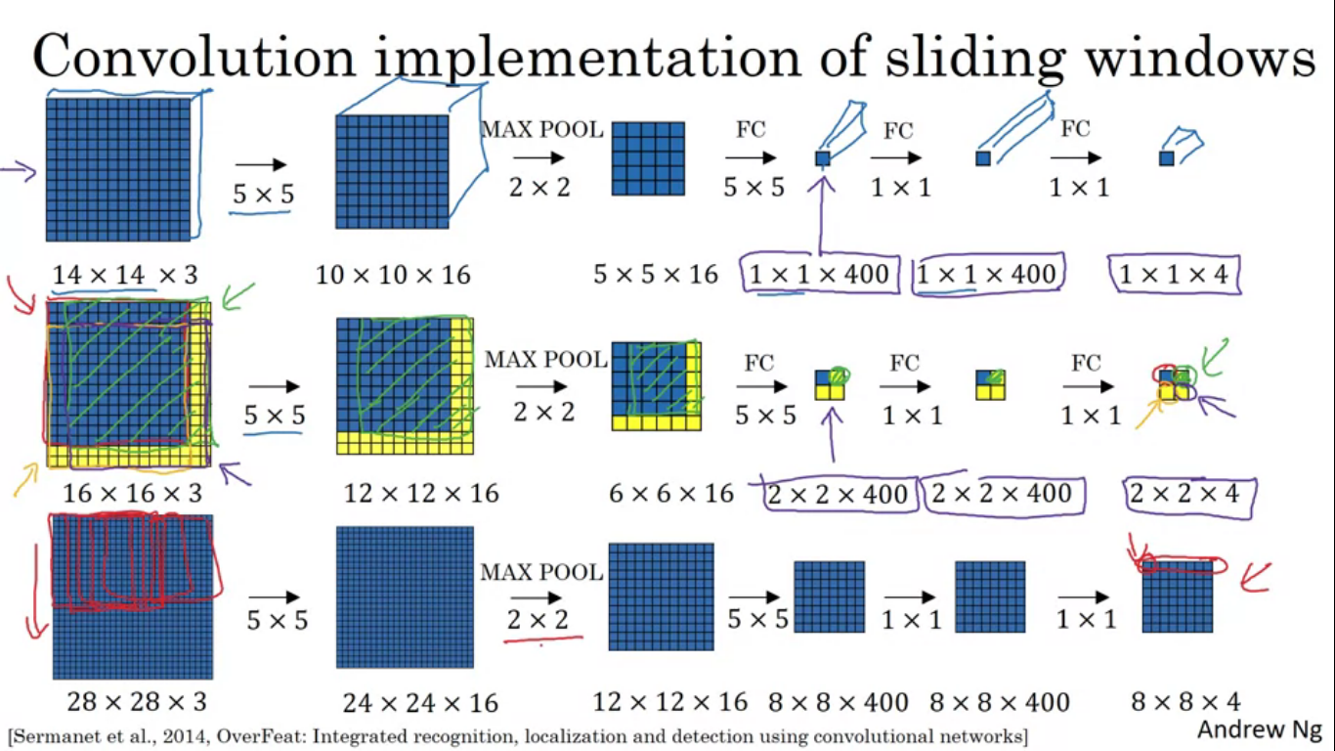

So conv net input is 14x14x3 and test set input is 16x16x3. So we run the conv with these four sets as shown but a lot of this computation is highly duplicative. So test input is 16x16x3 so we run it on the conv net with 5x5x16 filters giving us the output image size as 12x12x16. Do the max pool as before and get 6x6x16. For FC we use 400 5x5 filters to get 2x2x400 volume. So now instead of 1x1x400 volume you have 2x2x400 volume. Another run through 1x1 filter gives 2x2x400. Do it with the softmax and we are now left with a 2x2x4 volume instead of 1x1x4. The blue subset gives the result of running the upper left hand corner 14x14x image marked by red. The upper right yellow gives marked by green. Lower left gives orange region and lower right gives the purple region. So instead of running forward propagation on four subsets of images independently it combines all four into 1 forward prop. See the image to get a greater insight. Running NN with a stride of 2 as given max pool filter size of 2.

So instead of cropping out regions from the image and then inputting them to the conv net, you can input the entire image and make all the prediction at the same time by 1 forward pass and it will recognise the position of the car.

The above algorithm still has 1 weakness that is the position of bounding boxes is not going to be too accurate.

**Bounding boxes predictions**

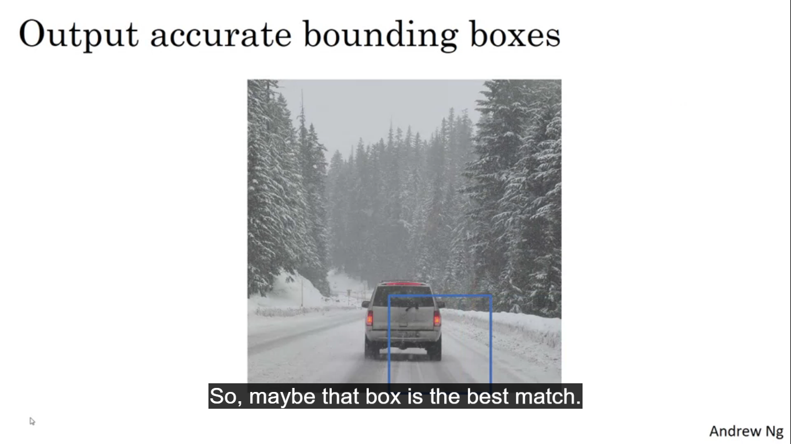

It may happen that when running the sliding window algorithm, none of the objects actually match completely with the car. A good way to output the perfect bounding boxes is with the YOLO algorithm. **YOLO stands for, You Only Look Once.** On an input image we place down a grid, here shown as 3x3 grid although in actual implementation we use a finer one like maybe a 19x19 grid. We are going to take the image classification and localization algorithm and apply it to each of the 9 grids.

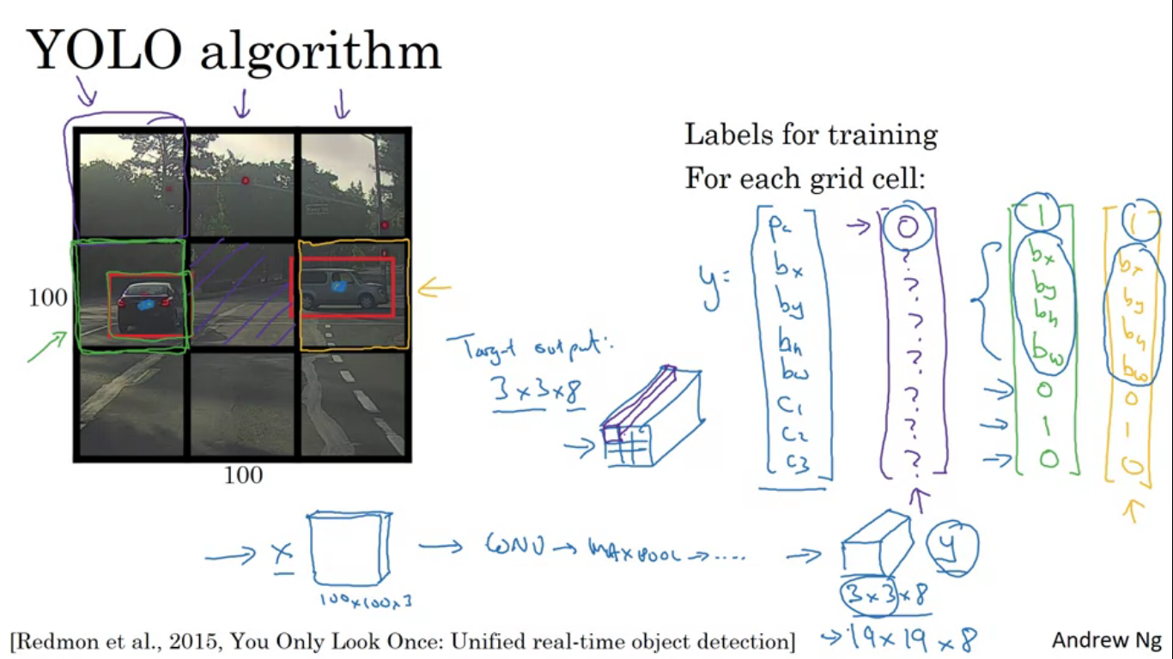

For each of the 9 cells we have a 8th dimension vector of label Y. So for each of the 9 grid cells we find out Y. What about an image with two objects? What YOLO algorithm does it takes the mid point of each of the two objects and assigns the object to the grid cell containing the mid point. So left car is assigned to green marked cell and other car is assigned to the cars range grid. Even though the central grid cell has some part of both we will pretend the central grid cell ahs no interesting object.

For each of the nine grid cells we end up with a 8th dimensional output vector. The total volume of the output is going to be 3x3x8. So we have the input and we have to choose the conv layers and max pool layers so that it eventually maps to a 3x3x8 output volume. We use BP to train the NN to map from any input X to this type of output volume Y.

Advantage is that the NN outputs precise bounding boxes. This is a convolutional implementation we are not implementing the algorithms nine times. This is one single convolutional implementation where we use one conv net with a lot of shared computation between all the computations needed for all the cells.

How do we encode the bounding boxes bx, by, bw, bh?

Let’s take the cell containing the car so pc = 1 for that. Then bx = 0.4, by = 0.3, bh = 0.9, bw= 0.5. these four quantities are specified relative to grid cell. Bx and by has to be between 0 and 1, whereas bh and bw >1

**Intersection over union (IOU)**

How do we tell if the object detection algorithm is working well? A function known as intersection over union is used for evaluating the algorithm as well add another component to object detection algorithm. Let say we have two bounding boxes so IOU computes the intersection over union of these two bounding boxes.

**IOU = size of intersection / size of union**

The answer is correct if IOU>=0.5.

If the predicted and ground truth boxes intersected perfectly the IOU will be 1. Higher the IOU more accurate the bounding box.

This is one way to map localization to accuracy where you just counts up the number of times an algorithm correctly detects and localizes an object .

Motivation behind IOU to determine whether your object localization algorithm is correct or not?

More generally IOU is a measure of overlap between two bounding boxes. It is also a way of measuring how similar two boxes are to each other.

**Non max suppression**

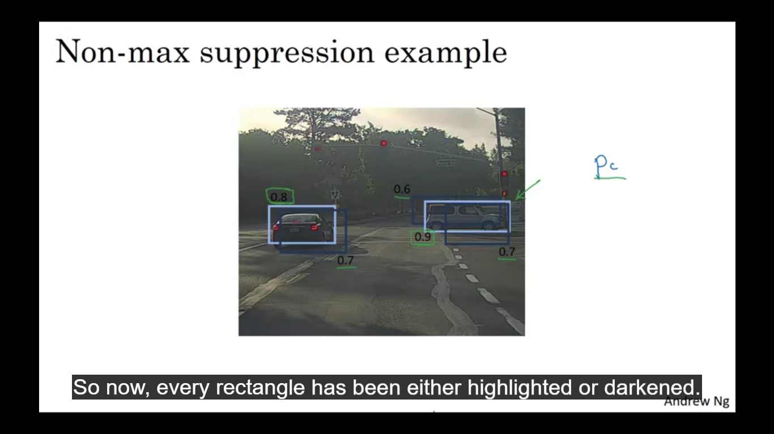

Your algorithm may find multiple detections of the same object, rather than detecting an object just once it might detect it multiple times. Non max suppression is a way to make sure that your algorithm detects each object only once.

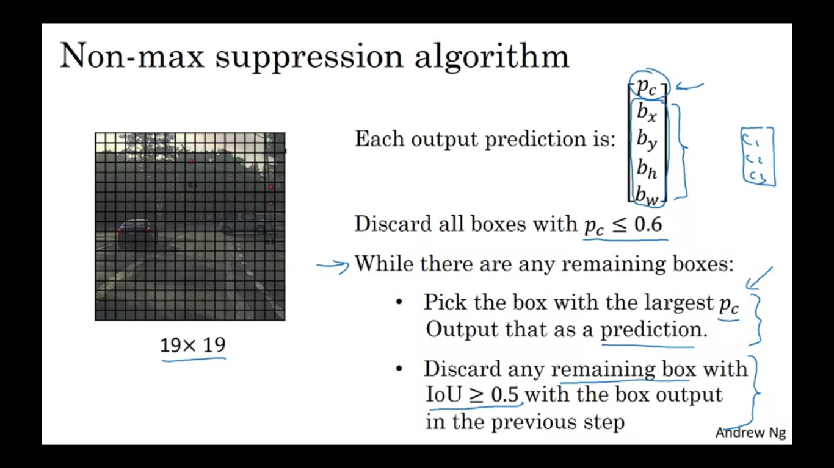

Let’s say we want to detect pedestrians, cars and motorcycles in this image. We have a 19x19 grid, technically this car has just one mid point so it should be assigned to just one grid cell. In practice you are running object classification and localization for every one of these grid cells. So some of the cells may think that center of the car is in their cell. This will end in multiple detections of each object. Non max suppressions cleans up these detections so that the objects end up with just one detection per car. It first looks at the probabilities associated with each of these detections. Which is pc with the probability of detection. It first takes the largest one and highlights it saying it found a car there. Then it looks at all of the remaining rectangles and all of the ones with high overlap. So rectangles with 0.6 and 0.7 those overlap a lot with 0.9 rectangle so they will be suppressed. Next go through the remaining rectangles and find the ones with highest probability which in second car is 0.8. then he non max suppression part is to get rid of any other ones with higher IOU. The highlighted ones are our two final predictions.

We can also have a bounding box probability threshold as a value like for example 0.6. all the bounding boxes which are assigned low probability are vanished.

**Anchor Boxes**

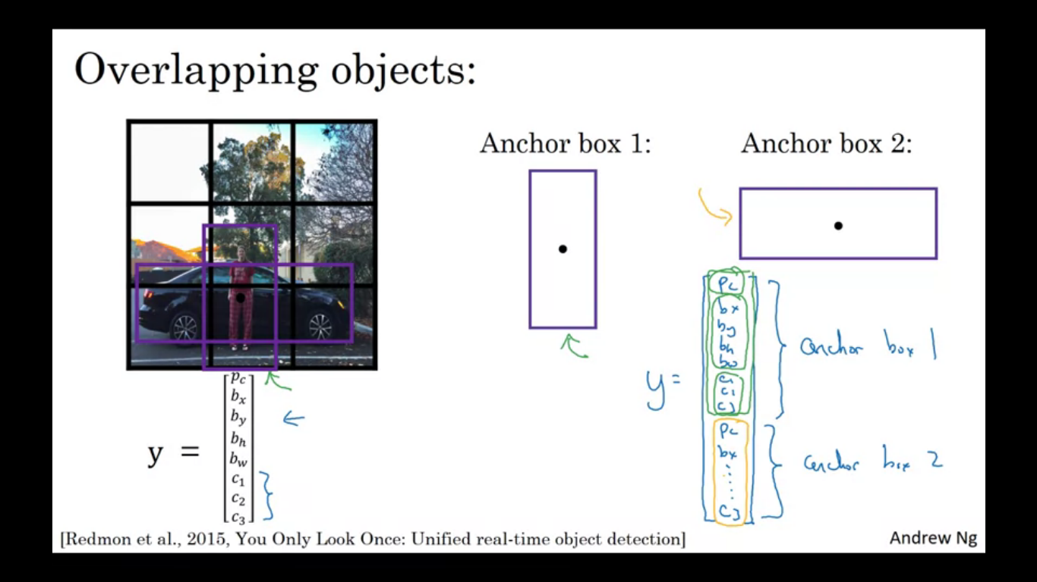

One of the problems with object detection is each of grid cells can detect only one object. What if the grid cells want to detect multiple object. For that we can use the idea of anchor boxes.

For the image example the mid point of the pedestrian and the mid point of the car are in almost the same place and both of them fall into the same grid cell. For that grid cell Y outputs a vector where you detect three classes it won’t be able to output two detections. So we have to pick one of the two detections to output. With the idea of anchor boxes, predefine two different shapes called anchor boxes, so now we would be able to associate two predictions with two anchor boxes. So we define the class label to be as shown in the image. So we create a separate encoding for the two objects.

Before using anchor boxes we did the following –

Each object in the training image is assigned to the grid cell that contains that object’s mid point. Output Y was 3x3x8 as known previously.

With the anchor boxes each object in training image is assigned to the same grid cell that contains object’s mid point and anchor box for the grid cell with the highest IOU gets assigned to (grid cell, anchor box) pair. Now output Y is going o be 3x3x16. As now there are two anchor boxes and Y is eight dimensional.

For the complete example if the image only had a car and we had two bounding boxes then for the second anchor box the values will be same but for the upper part i.e. anchor box 1 which is more suited for pedestrians, its pc = 0 and the rest we don’t care.

What if we had two anchor boxes but three objects in the same grid cell?

What if we have two objects in the same grid cell but both of them have the same anchor box shape?

In the above cases the algorithm does not work well.

**YOLO algorithm**

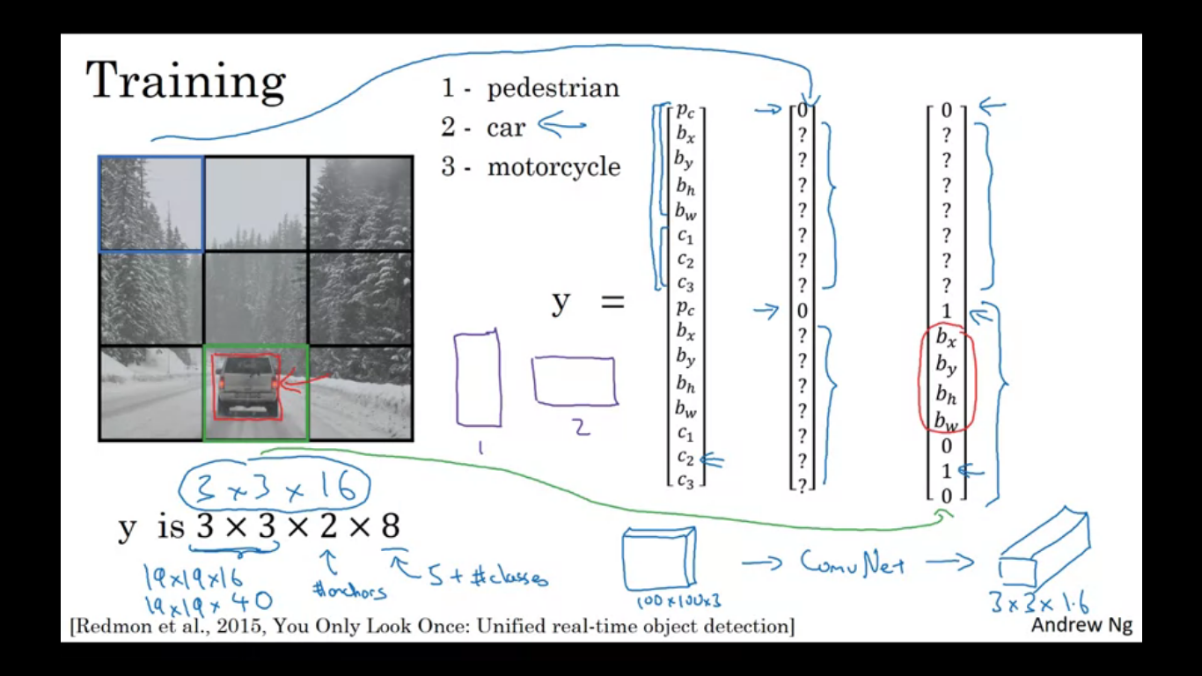

**Training**

Suppose we have to train an algorithm that detects three objects pedestrians cars and motorcycles. If we are using two anchor boxes the output Y will be 3x3x2x8, where 2 is the number of anchors. To construct the training set you go through each of these 9 training cells and for m the appropriate target vector Y. For the box containing the car, we would have the different target vector Y which is as shown in the image.

**Predictions**

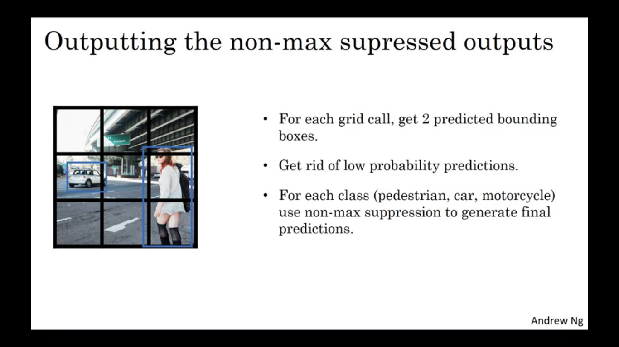

For the box marked in green hopefully the value of output label Y will be nearby to the target value.

Finally run this through non max suppression

For each of the nine grid cells we get two bounding boxes as shown, notice some of the bounding boxes can go outside the height and width of the grid cell. Then we get rid of the low probability prediction. Finally for each of the three classes we use non max suppression to generate the final output.

**R-CNN**

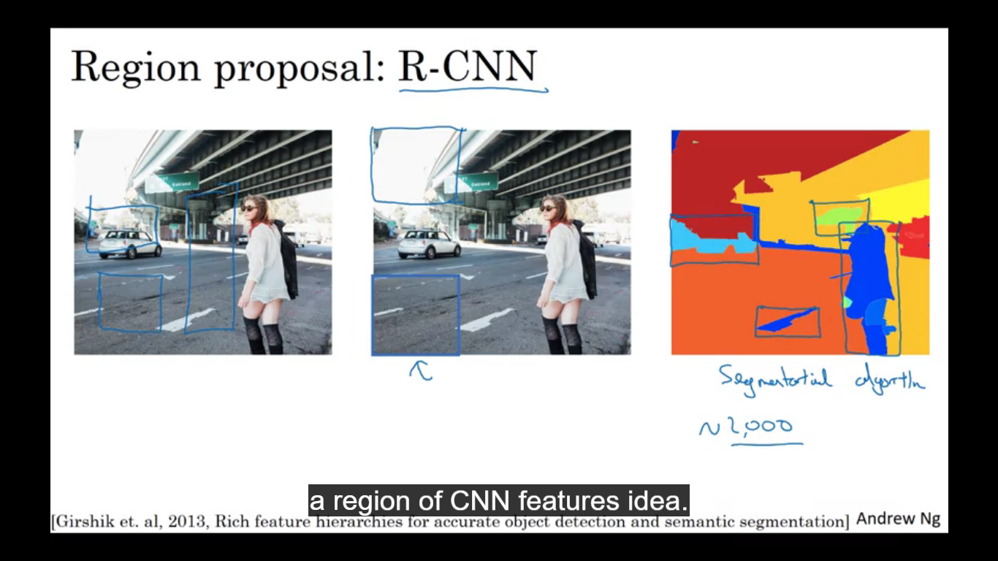

It tries to pick just a few regions that make sense to our conv net classifier. So rather than running sliding window on every single window you instead select just a few windows and run your conv net classifier on those windows. The way to perform the region proposals is to run an algorithm called segmentation algorithm. Segmentation algorithm finds blobs on which we run our conv net.

R-CNN is a slow algorithm so there has been line of work to explore how to speed up the algorithm.